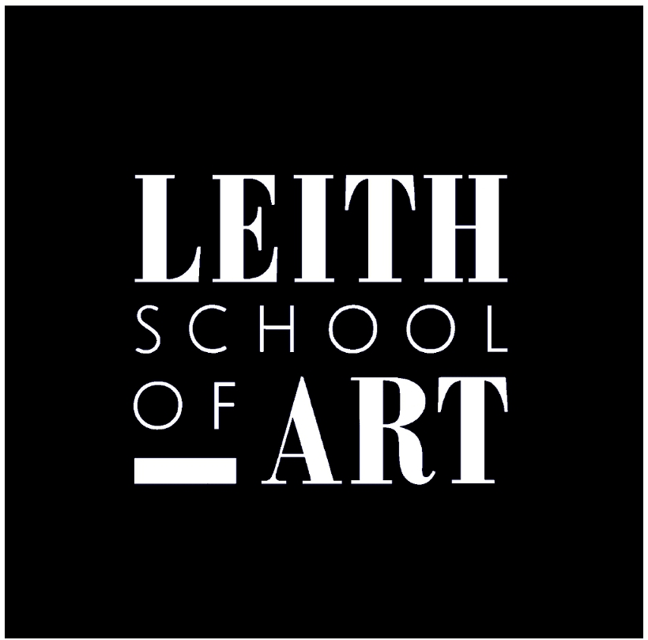
The Leith School of Art
25 North Junction Street
Edinburgh EH6 6HW

Telephone: 0131 554 5761
Web: www.LeithSchoolofArt.co.uk
Email: enquiries@LeithSchoolofArt.co.uk

Application for Community Class
Title:
Forename(s):
Surname:
Address:

Address: | Postcode:
Telephone (Day):
Telephone (Mobile):
Email Address:
Supporting evidence of state benefit enclosed:
(Please list all documents you are sending)
 |  | Please note we accept the following: Job Seekers’ Allowance, Income Support, Child Tax Credit, Working Tax Credit, Housing Benefit, Employment and Support Allowance, Disability Living Allowance and Attendance Allowance or Severe Disablement Allowance, or your sole source of income is a DWP State Retirement Pension and Pension Credit.

Please tick which class you would like to join: | Monday Afternoon (2pm – 4:30pm) |  | Tuesday Morning (10am - 12:30pm)
Please tick which class you would like to join: | Tuesday Afternoon (2pm – 4:30pm)

Signed:

Date:

Please complete and send to: Ashley Murray, Short Courses Administrator, Leith School of Art, 25 North Junction Street, Edinburgh, EH6 6HW. Email: Ashley@LeithSchoolofArt.co.uk

The Leith School of Art is a Company Limited by Guarantee and having Charitable Status.
Registered in Scotland at 25 North Junction Street, Edinburgh.
Registered No.111089. Scottish Charity Number SCO07456ED327/88.

